**Code:**

#include <stdio.h>

int main(){

    char ch;

    printf("enter a character: ");

    scanf("%c", &ch);

    if(ch >= 'A' && ch <= 'Z' || ch >= 'a' && ch <= 'z'){

        printf("%c is alphabet", ch);

    }

    else if(ch >= '0' && ch <= '9' ){

        printf("%c is digit", ch);

    }

    else{

        printf("%c is special symbol", ch);

    }

    return 0;

}

**Output:**

Test Case 1:



Test Case 2:



Test Case 3:



**Code:**

#include <stdio.h>

int isValidTriangle(double side1, double side2, double side3)

{

    if (side1 + side2 <= side3) return 0;

    if (side2 + side3 <= side1) return 0;

    if (side3 + side1 <= side2) return 0;

    return 1;

}

char* typeOfTriangle(double side1, double side2, double side3){

    if(side1 == side2 && side2 == side3) return "equilateral";

    if(side1 == side2 || side2 == side3 || side1 == side3) return "isosceles";

    return "scalene";

}

int main()

{

    double side1, side2, side3;

    printf("Enter all three sides of a triangle: ");

    scanf("%lf %lf %lf", &side1, &side2, &side3);

    if(isValidTriangle(side1, side2, side3)){

        printf("%s", typeOfTriangle(side1, side2, side3));

    }

    else{

        printf("Invalid triangle");

    }

    return 0;

}

**Output:**

Test Case 1:



Test Case 2:



Test Case 3:



Test Case 4:

  
**Code:**

#include <stdio.h>

int main(){

    // taking the input

    int sub1Marks, sub2Marks, sub3Marks;

    printf("enter the masks of all three subjects: ");

    scanf("%d %d %d", &sub1Marks, &sub2Marks, &sub3Marks);

    //calculating the percentage

    const int TOTAL_MARKS = 300;

    const long int SEM_FEE = 125000;

    int obtained = sub1Marks + sub2Marks + sub3Marks;

    float percentage = (float)obtained / TOTAL_MARKS * 100;

    int scholarship = 0;

    if(percentage < 50) scholarship = 0;

    else if(percentage < 61) scholarship = 5;

    else if(percentage < 75) scholarship = 20;

    else if(percentage < 85) scholarship = 30;

    else scholarship = 50;

    long int discount = SEM_FEE * scholarship / 100;

    long int payableAmount = SEM_FEE - discount;

    printf("Obtained Marks: %d\n", obtained);

    printf("Your Percentage %f%%\n", percentage);

    printf("Your Semester Fee is : %lld\n", SEM_FEE);

    printf("Your Scholarship is : %d%%\n", scholarship);

    printf("You Got Discount of : %lld%\n", discount);

    printf("Your Net Payable Ammount : %lld%\n", payableAmount);

    return 0;

}

**Output:**

Test Case 1:



Test Case 2:



Test Case 3:



Test Case 4:

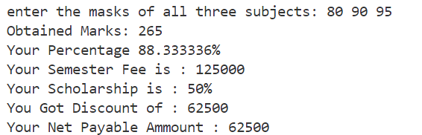

**Code:**

#include <stdio.h>

int isLeap(int year)

{

    if (year % 100 == 0 && year % 400 == 0) return 1;

    if (year % 100 != 0 && year % 4 == 0) return 1;

    return 0;

}

int main()

{

    int year;

    printf("Enter the year: ");

    scanf("%d", &year);

    printf(isLeap(year) ? "leap" : "not leap");

    return 0;

}

**Output:**

Test Case 1:



Test Case 2:



**Code:**

#include <stdio.h>

int isPalindrome(int num)

{

    int rev = 0;

    int temp = num;

    while (temp)

    {

        rev = rev * 10 + (temp % 10);

        temp /= 10;

    }

    return rev == num;

}

int main()

{

    int n;

    printf("Enter the n: ");

    scanf("%d", &n);

    int i, count;

    i = count = 1;

    while (count <= n)

    {

        if (isPalindrome(i))

        {

            printf("%3d %d\n", count++, i);

        }

        i++;

    }

    return 0;

}

**Output:**

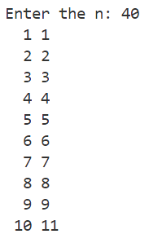 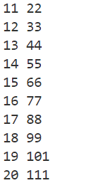  

**Code:**

#include <stdio.h>

#include <math.h>

void convert(long long num, char type) {

    int mask, maskSize;

    int size = sizeof(num) * 8;

    const char *prefix;

    switch (type) {

        case 'b': (mask = 0b0001, maskSize = 1, prefix = "0b "); break;

        case 'o': (mask = 0b0111, maskSize = 3, prefix = "0 "); break;

        case 'h': (mask = 0b1111, maskSize = 4, prefix = "0x "); break;

        default:  printf("Invalid Type\n"); return;

    }

    printf("%s", prefix);

    int segments = ceil((float)size / maskSize) - 1;

    int val, leadingZeros = 1;

    for(int i = segments; i >= 0; --i){

        val = num >> (i * maskSize) & mask;

if(val != 0) leadingZero = 0;

        if(val > 9){

            printf("%c", 'a' + val % 10);

        }

        else{

            printf("%d", val);

        }

    }

    printf("\n");

}

int main() {

    long long int decimalNum;

    printf("enter a decimal number: ");

    scanf("%lld", &decimalNum);

    convert(decimalNum, 'h');

    convert(decimalNum, 'o');

    convert(decimalNum, 'b');

    return 0;

}

**Output:**

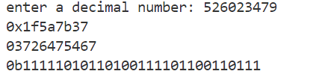 **Code:**

#include <stdio.h>

char* digitToString(int digit){

    switch (digit)

    {

        case 0: return "Zero";

        case 1: return "One";

        case 2: return "Two";

        case 3: return "Three";

        case 4: return "Four";

        case 5: return "Five";

        case 6: return "Six";

        case 7: return "Seven";

        case 8: return "Eight";

        case 9: return "Nine";

        default: return "";

    }

}

void print(int num){

    if(!num) return;

    print(num / 10);

    printf("%s ", digitToString(num % 10));

}

int main(){

    int num;

    printf("enter a number: ");

    scanf("%d", &num);

    print(num);

    return 0;

}

**Output:**

 **Code:**

#include <stdio.h>

#include <math.h>

double series1(int i, int fact){

    return pow(i, i)/fact;

}

double series2(int i, int fact){

    return pow(i, i-1)/fact;

}

double series3(int i, int fact){

    return (i & 1)? fact : -fact;

}

double accumulat(int n, double (*callback)(int, int)){

    double sum = 0;

    int fact = 1;

    for(int i = 1; i<= n; ++i){

        fact *= i;

        sum += callback(i, fact);

    }

    return sum;

}

int main(){

    int n;

    printf("enter the nth term: ");

    scanf("%d", &n);

    printf("Series 1: %lf\n", accumulat(n, series1));

    printf("Series 2: %lf\n", accumulat(n, series2));

    printf("Series 3: %lf\n", accumulat(n, series3));

    return 0;

}

**Output:**

**Code:**

#include <stdio.h>

int HCF(int num1, int num2){

    int rem;

    do

    {

        rem = num1 % num2;

        num1 = num2;

        num2 = rem;

    } while (num2 != 0);

    return num1;

}

int LCM(int num1, int num2){

    return (num1 * num2) / HCF(num1, num2);

}

int main(){

    int num1, num2;

    printf("Enter two numbers: ");

    scanf("%d %d", &num1, &num2);

    printf("LCM: %d\n", LCM(num1, num2));

    printf("HCF: %d\n", HCF(num1, num2));

}

**Output:**



**Code:**

#include <stdio.h>

int main(){

    int n;

    printf("Enter the nth Term: ");

    scanf("%d", &n);

    // =============== pattern 1

    for(int i = 1; i<=n; ++i){

        for(int j = 1; j<= n - i; ++j){

            printf("  ");

        }

        for(int j = 1; j<=i; ++j){

            printf("%d ", j);

        }

        for(int j = i - 1; j >= 1; --j){

            printf("%d ", j);

        }

        printf("\n");

    }

    for(int i = 2; i<=n; ++i){

        for(int j = 1; j < i; ++j){

            printf("  ");

        }

        for(int j = 1; j<=n + 1 - i; ++j){

            printf("%d ", j);

        }

        for(int j = n - i; j >= 1; --j){

            printf("%d ", j);

        }

        printf("\n");

    }

    // =============== pattern 2

    printf("\n\n");

    for(int i = 1; i<=n; ++i){

        for(int j = 1; j<= n - i; ++j){

            printf("  ");

        }

        for(int j = n; j > n - i; j--){

            printf("%c ", j + 'A' - 1);

        }

        for(int j = n+2-i; j<=n; ++j){

            printf("%c ", j + 'A' - 1);

        }

        printf("\n");

    }

    for(int i = 2; i<=n; ++i){

        for(int j = 1; j< i; ++j){

            printf("  ");

        }

        for(int j = n; j >= i; j--){

            printf("%c ", j + 'A' - 1);

        }

        for(int j = i + 1; j<=n; ++j){

            printf("%c ", j + 'A' - 1);

        }

        printf("\n");

    }

    return 0;

}

**Output:**

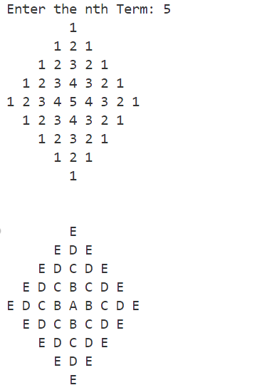

**Code:**

#include <stdio.h>

struct Time{

    int hour;

    int minut;

    int second;

};

void input(struct Time *time){

    printf("enter time (hh mm ss) ");

    scanf("%d %d %d", &time->hour, &time->minut, &time->second);

}

void output(struct Time *time){

    printf("%02d:%02d:%02d\n", time->hour, time->minut, time->second);

}

struct Time sum(struct Time *t1, struct Time *t2){

    struct Time result;

    result.second = (t1->second + t2->second);

    result.minut = (t1->minut + t2->minut)  + (result.second / 60);

    result.hour = (t1->hour + t2->hour) + (result.minut / 60);

    result.second %= 60;

    result.minut %= 60;

    result.hour %= 60;

    return result;

}

int main(){

    struct Time t1, t2, t3;

    input(&t1);

    input(&t2);

    t3 = sum(&t1, &t2);

    output(&t1);

    output(&t2);

    output(&t3);

}

**Output:**

